Project Design Phase-II
Technology Stack (Architecture & Stack)

Date | 7 October 2026
Team ID
Project Name | Script-Controlled ACL – Restrict Record Access Based on Field Value
Maximum Marks | 4 Marks

Technical Architecture:
The Deliverable shall include the architectural diagram as below and the information as per the table1 & table 2
Example: Script-Controlled ACL – Restrict Record Access Based on Field Value
Reference: https://www.servicenow.com/docs/r/oJu9n0q6rU~F9UHAnNCt5w/aGZqCO71IpYGqS0MTeJC7Q
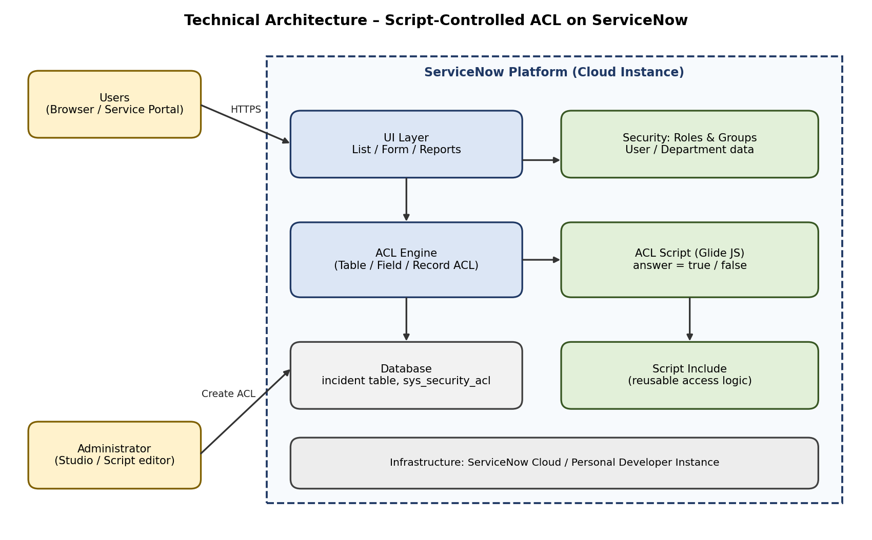
Table-1 : Components & Technologies:
S.No | Component | Description | Technology
1. | User Interface | How the user opens records: list view, form view and reports | ServiceNow UI (Next Experience), Service Portal
2. | Application Logic-1 | ACL script that checks the field value and the logged-in user (answer = true / false) | JavaScript (Glide API), ServiceNow ACL
3. | Application Logic-2 | Reusable access logic called from the ACL script | Script Include (JavaScript)
4. | Application Logic-3 | Role and group check for privileged users | gs.hasRole(), User Groups
5. | Database | Records table and ACL rules storage | ServiceNow tables: incident (example), sys_security_acl
6. | Cloud Database | Database service provided with the instance | ServiceNow cloud instance database
7. | File Storage | Not required for this project (record attachments follow the same table ACL) | Not applicable
8. | External API-1 | Not required for the core ACL logic | Not applicable
9. | External API-2 | Optional: verify access through the REST Table API during testing | ServiceNow REST API
10. | Machine Learning Model | Not required for this project | Not applicable
11. | Infrastructure (Server / Cloud) | Application development and testing on a ServiceNow instance | ServiceNow Personal Developer Instance (Cloud)
Table-2: Application Characteristics:
S.No | Characteristics | Description | Technology
1. | Open-Source Frameworks | The solution uses the built-in ServiceNow platform; no open-source framework is required | Not applicable
2. | Security Implementations | Record-level access control using roles and a script condition; deny unless the script returns true | ServiceNow ACL, Roles, Groups
3. | Scalable Architecture | The same Script Include and ACL pattern can be reused for other tables and field values | Script Include, ACL
4. | Availability | Rule runs inside the platform, so availability follows the ServiceNow instance | ServiceNow Cloud
5. | Performance | Keep the ACL script light: no heavy GlideRecord queries, check only the required fields | Optimised Glide scripting
References:
https://www.servicenow.com/docs/r/yokohama/platform-security/access-control/exploring-access-control-list.html?contentId=oczJQGZK~1lGzH~ITrwZHg
https://www.servicenow.com/docs/r/oJu9n0q6rU~F9UHAnNCt5w/aGZqCO71IpYGqS0MTeJC7Q
https://www.servicenow.com/docs/r/application-development/servicenow-sdk/acl-api-now-ts.html

